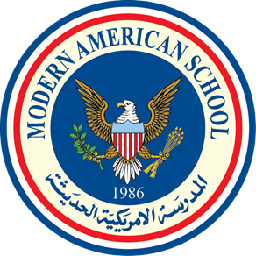

MODERN AMERICAN SCHOOL

Accredited by the American Board ADVANC-ED (COGNIA)

Members of the NEW EAST SOUTH ASIA Council of Overseas Schools (NESA) & Council of International Schools (CIS) Affiliated with AMIDEAST ♦ College Board (SAT/AP) ♦ ACT ♦ British Council

Student Reference Form for Applicants/English
Student’s Name:
MAS is an authorized school to implement the International Baccalaureate Diploma Programme (IBDP) and is accredited by COGNIA (AdvancED) for schools. The Modern American School aims at fostering a high standard of bilingual, comprehensive education from its pre-Kg through Grade 12 programs that meets and integrates both national and international standards.

Skills | Above Grade Level | At Grade Level | Below  Grade Level
Writing: Coherence, Cohesion & Creativity
Reading: Comprehension, Analysis & Interpretation
Fluency in Speaking
Listening
Diction (Word Choice)
Organization and Presentation
Mechanics & Conventions (Grammar)
Research
Study Skills

Comment:

Cognitive Development | Consistently | Sometimes | Not yet
Enjoys learning
Is imaginative & creative
Follows directions
Tries new ideas
Seeks help when necessary
Contributes to class discussions
Meets deadlines
Respects classroom rules/routines
Able to work in groups

Comment:

Social Development | Consistently | Sometimes | Not yet
Has a tendency to lead effectively
Has a tendency to follow instructions appropriately
Easily adjusts to changes
Exhibits respectful attitude toward teachers
Exhibits positive attitude toward peers
Accepts suggestions and criticism
Accepts responsibilities for actions

Comment:

Additional Information:

- Please list the applicant’s talents and/or strengths.

- Please describe any impairment the applicant has in speech, hearing, vision, learning, socialization or physical coordination. Please include accommodations and modifications provided.

- Is there any additional information that would be helpful about this student?

Teacher’s Name: Date:

Email: Signature:

School Stamp:

