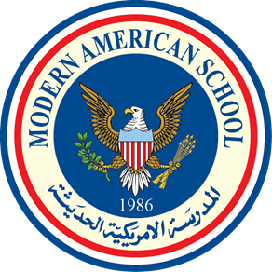

MODERN AMERICAN SCHOOL

Accredited by the American Board ADVANC-ED (COGNIA)

Members of the NEW EAST SOUTH ASIA Council of Overseas Schools (NESA) & Council of International Schools (CIS) Affiliated with AMIDEAST ♦ College Board (SAT/AP) ♦ ACT ♦ British Council

Student Reference Form for Applicants/Math
Student’s Name:
MAS is an authorized school to implement the International Baccalaureate Diploma Programme (IBDP) and is accredited by COGNIA (AdvancED) for schools. The Modern American School aims at fostering a high standard of bilingual, comprehensive education from its pre-Kg through Grade 12 programs that meets and integrates both national and international standards.

Academic Skills | Above Grade Level | At Grade Level | Below  Grade Level
Math Facts/Computation skills
Problem Solving
Oral Expression
Organization
Retention and Application of Skills
Initiative
Open- mindedness
Retention and Application of Skills
Mental Math

Comment:

Cognitive Development | Consistently | Sometimes | Not yet
Enjoys learning
Is imaginative
Follows directions
Tries new class activities willingly
Seeks help when necessary
Contributes to class discussion
Completes assigned tasks in the allotted time
Respects classroom rules/routines
Able to work in groups

Comment:

Social Development | Consistently | Sometimes | Not yet
Has a tendency to lead appropriately
Has a tendency to follow instructions appropriately
Easily adjusts to changes in routine
Exhibits respectful attitude toward teachers
Exhibits positive attitude toward peer(s)
Accepts suggestions and criticism
Accepts responsibilities for actions

Comment:

Additional Information:

- Please list the applicant’s talents and/or strengths.

- Please describe any impairment the applicant has in speech, hearing, vision, learning, socialization or physical coordination. Please include accommodations and modifications provided.

- Is there any additional information that would be helpful about this student?

Teacher’s Name: Date:

Email: Signature:

School Stamp:

