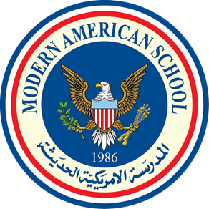

MODERN AMERICAN SCHOOL

Accredited by the American Board ADVANC-ED (COGNIA)

Members of the NEW EAST SOUTH ASIA Council of Overseas Schools (NESA) & Council of International Schools (CIS) Affiliated with AMIDEAST ♦ College Board (SAT/AP) ♦ ACT ♦ British Council

Confidential Principal/Academic School Counselor Recommendation Letter

The following student has requested that you complete this evaluation on his/her behalf. The information provided will be used for the scholarship assessment report and will be kept confidential. Please complete this form and return it to the Admission Office. Thank you.

Student's Name:

How long have you known this student?

What are the first words that come to your mind to describe this student?

_______________________________________________________________________________________________

Compared to other students in his/her class year, how do you rate this student in terms of:

 | No Basis | Below Average | Average | Good | Excellent | Outstanding
Intellectual Promise
Performance
Productive class discussion
Quality of writing
Academic motivation
Creativity
Initiative
Self-discipline
Genuine interest in learning
Sense of humor
Independence
Leadership
Self-confidence
Warmth of personality
Reaction to setbacks
Reaction to criticism
Respect accorded by faculty
Respect accorded by classmates

Confidential Comments (Please write whatever you think is important about this student, including a description of academic and personal characteristics, as demonstrated in your division):

Recommendation | Without Enthusiasm | With Fair Enthusiasm | Strongly | Enthusiastically | Highest Recommendation
For academic and scholarship promise
For character and personal promise

______________________________________________________________________________

Principal/Counselor Name:

Signature: -

School Official Stamp

